**P250/1**

**GEOGRAPHY**

**(Physical**

**Geography)**

***🕮***

***🖎***

**Community**

UNNASE MOCK EXAMINATIONS

**Paper I**

**August, 2019**

**3 hours**

***Uganda Advanced Certificate of Education***

**GEOGRAPHY**

**(PHYSICAL GEOGRAPHY)**

**PAPER I**

**3 HOURS**

**Instructions to Candidates**

* *Answer* ***four*** *questions in all.*
* *Section A is compulsory.*
* *Answer* ***one*** *question from Section B and* ***one*** *from Section C.*
* *Credit will be given for the use of relevant sketch maps and diagrams and specific examples studied in the field.*
* *Any additional question(s) attempted will* ***not*** *be marked.*

**SECTION A: MAP WORK AND PHOTOGRAPHIC INTERPRETATION**

1. Study the EAST AFRICA 1:50,000 (UGANDA), **ALOI** Map extract; Series Y732, sheet, 33/1; Edition 1-U.S.D. and answer the following questions.
2. (i) State the grid reference of primary trigonometrical station South East of Aloi town. *(01 mark)*

(ii) Name the man-made feature found at grid reference 189514.

*(01 mark)*

1. Determine the de-tour index of the all-weather road from grid reference 277504 to grid reference 254640 *(03 marks)*

1. (i) Reduce the area shown on the map extract to 40%and on the sketch mark and label the following:

* **Two** main physiographic features
* **Two** types oftransport routes.
* Any **one** dam
* River Aloi and tributaries *(1*0 *marks)*

(ii) Calculate the scale of the sketch map drawn. *(02 marks)*

1. (i) Account for the dominant drainage pattern exhibited in the area on the map extract. *(04 marks)*

(ii) Explain how relief has generally influenced the nature of drainage in the area shown on the map extract. *(04 marks)*

1. Study the photograph provided below and answer the questions that follow:

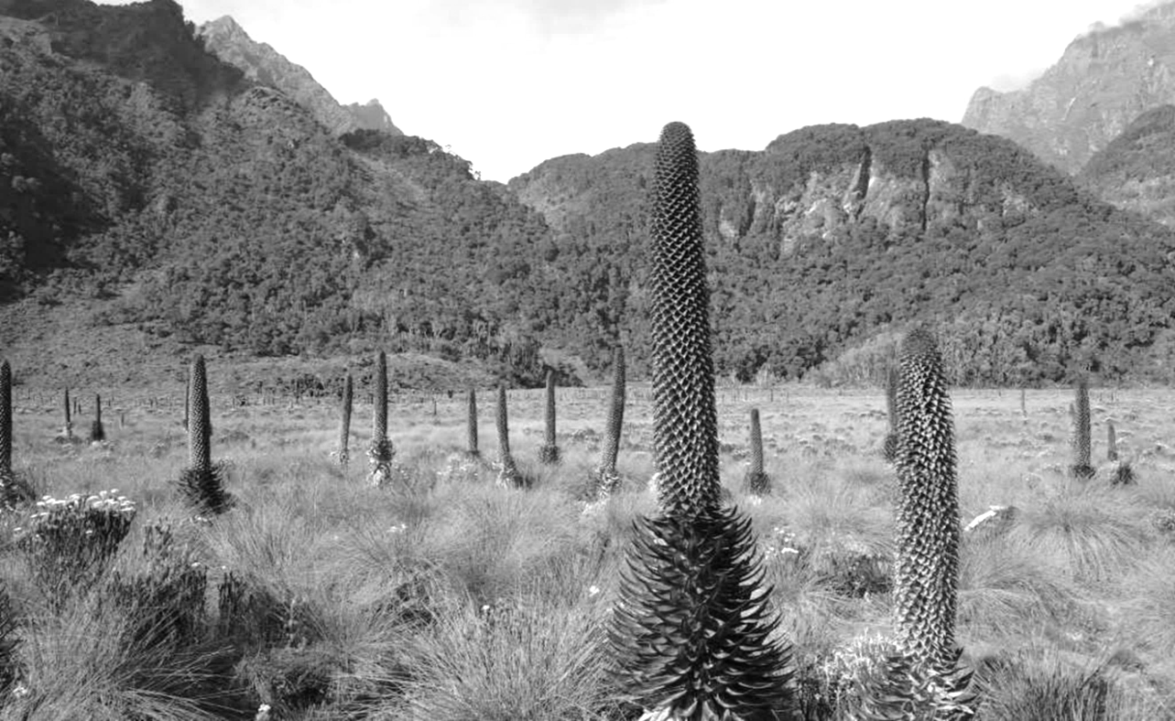

(a) Draw a landscape sketch of the area shown on the photograph and on it mark and label the:

1. **Two** relief regions
2. **Three** vegetation types
3. Bare rocks *(09 marks)*
4. (i) Describe the characteristics of the nature of vegetation in the area shown in the photograph. *(05 marks)*
5. Identify the economic activities that may be associated with the vegetation in the photograph. *(03 marks)*
6. Explain the factors that have influenced the growth of the kind of vegetation in the area shown on the photograph *(05 marks)*
7. (i) What type of photograph is it? *(01 mark)*
8. Giving reasons for your answer, suggest an area in East Africa where this photograph could have been taken. *(02 marks)*

**SECTION B**

1. Examine the relevance of the theory of Plate tectonics to the evolution of continents. *(25 marks)*
2. Account for the occurrence of landslides in East Africa. *(25 marks)*
3. With reference to specific examples, account for the formation of landforms resulting from wave erosion in East Africa. *(25 marks)*

**SECTION C**

1. (a) Distinguish between Tropical cyclones and Tornadoes. *(10 marks)*

(b) Examine the effects of Tropical cyclones on environmental conditions in areas where they occur. *(15 marks)*

1. Relate the physical factors to the type of natural vegetation in East Africa. *(25 marks)*
2. To what extent has topography influenced the development of a soil catena in East Africa. *(25 marks)*

**\*\*\*\* END \*\*\*\***